“No Difference”
Shel Silverstein

Small as a peanut,
Big as a giant,
We’re all the same size
When we turn off the light.

Rich as a sultan,
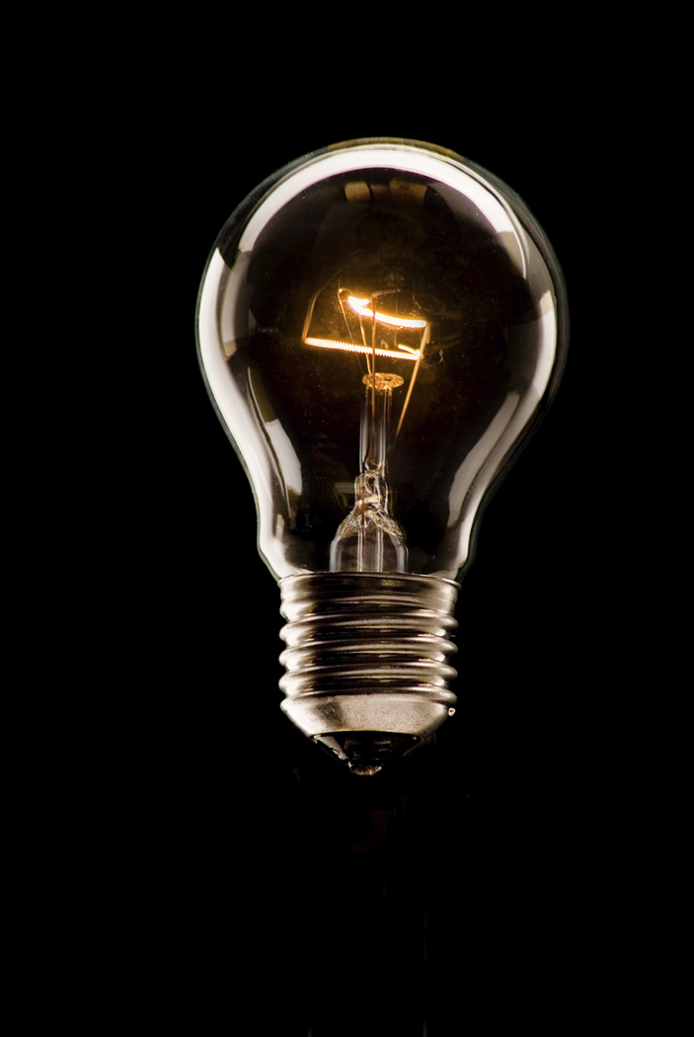
Poor as a mite,
We’re all worth the same
When we turn off the light.

Red, black or orange,
Yellow or white,
We all look the same
When we turn off the light.

So maybe the way
To make everything right
Is for someone to just reach out
And turn off the light!

